Ball Drop Experiment
Name
Institution Affiliations
Course Title
Date

Introduction
The concept of a bouncing ball is very important, especially in playing certain ball games. For instance, some ball games such as basketball playing require the bouncing of a ball. Dribbling a ball or just making a ball bounce can be a great exercise that involves energy use. When a ball hits the surface, it bounces back upwards. This bouncing back process converts some of its energy into a different form. If the dribbler does not put sufficient energy into the ball, the ball will not be able to dribble effectually. When a ball rebounds, it exerts two dissimilar kinds of energy that is kinetic energy and potential energy. Kinetic energy is one which is exerted on an object as a result of its motion while static energy is one which is stored in the ball and it is responsible for the motion such as the motion due to the height above the surface from which you drop a ball, (Diaconu, et al, 2019).
For instance, once you lift a ball at your waist height, it possesses some static energy. When you release the ball, the gravitational force pulls the ball downwards. As the ball drops, it transforms from potential energy to kinetic energy. When the ball hits the ground, some portion of the kinetic energy is transformed into sound, some into heat, and another portion of it used to slightly change the shape of the ball (flattening the ball slightly) while the rest of the energy is absorbed by the ground surface.
Equipment and Materials
- Different surfaces to bounce a ball on, with at least one hard surface and one soft surface.
- Tape measure
- Painter's tape or masking tape
- Basketball
- A smartphone (with installed accelerometer).
Procedure
- Prepare the different types of surfaces on which the ball will be bounced and set an estimated height from which the ball will be bounced. To do this, you can use a measuring tape along with masking tape to mark every specific inch from the ground. The measurements will go up to a certain maximum inches high from the ground. This can be done against a wall to mark the five heights which are the set inches apart, from where the ball is to be dropped.
- Set the video camera or accelerometer application on the phone and carefully mount it on the ball.
- Drop the ball (don’t push it) and obtain the elevation of the ball after it bounces upon hitting the ground.
- Repeat the dropping of the ball for the five height marks up to the 40 inches mark.
- Repeat the entire process for both the hard and soft surfaces and record the results.
Note:
To take estimations with the accelerometer in the Science Journal application, you initially need to pick which accelerometer you will utilize X, Y, Z, or Linear. When you have chosen which sensor to utilize, open the Science Journal application and start an investigation (or open a current analysis). Open the sensor apparatuses by tapping the sensor symbol on the dark toolbar and select the symbol for the particular accelerometer sensor (X, Y, Z, or Linear) you will use from the shaded bar indicating accessible sensors. This will open an accelerometer card for that sensor. The four accelerometer sensors accessible in Science Journal are shown underneath, (Schwarz, et al, 2013).
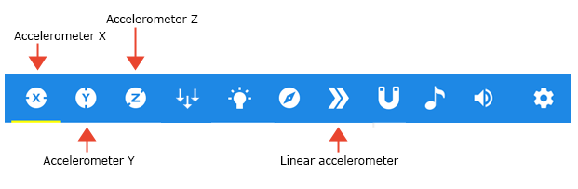
Observations and Results
One aspect that can influence the ball's bouncing with the surface is the kind of ground the ball lands on. At the point when a b-ball bobs off of a ground, a portion of its vitality is consumed by that ground. A few surfaces retain more energy than others do. (How much energy gets ingested decides the amount of energy the person dropping the ball to return to the ball to keep it dribbling.) A harder ground, for example, concrete, assimilates lesser energy contrasted and a delicate surface, a covered surface. The more the energy consumed by the ground, the less the energy which remains in the ball for it to bounce. This is the reason we ought to have noticed that when we dropped the ball on a moderately harder surface it bobbed higher (it lost lesser energy) contrasted and when it has bounced on a milder surface (where it lost higher amount of energy). For instance, contingent upon the kind of ball and the ground, we have seen the ball skip around 15 inches high on the cover and around 25 inches high on the harder surface.
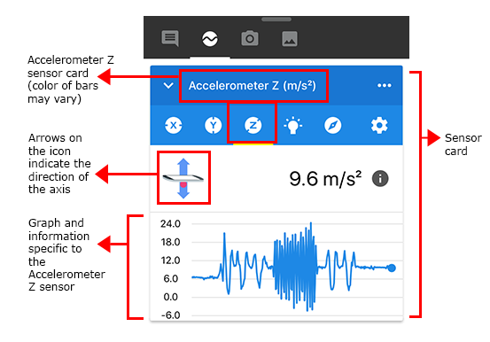
The graph in the screenshot above shows records of the acceleration and the bouncing graph of the ball as it is bounced on hard ground. The acceleration is higher because the harder ground absorbs less energy, hence the ball bounces at higher acceleration. The ball also dribbles for a longer time as shown on the graph since the surface absorbs less of its energy.
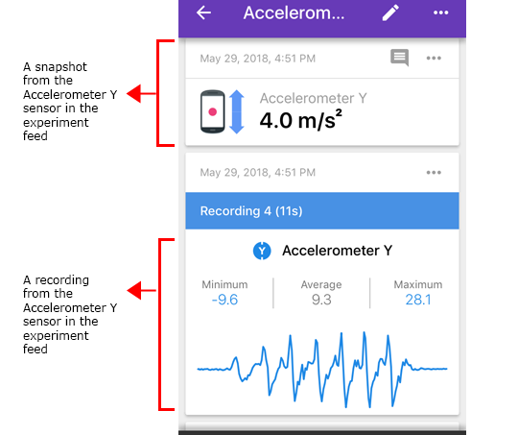
The screenshot above shows the record of the acceleration and dribbling graph of the ball when it is bouncing on softer ground. The bouncing acceleration is lower than that obtained when the ball is bounced on a harder ground since the soft ground absorbs more energy from the ball. The dribbling graph is also stretched for less time and rises to a less height compared to that obtained from the harder surface since the softer surface absorbs much of the energy of the ball.

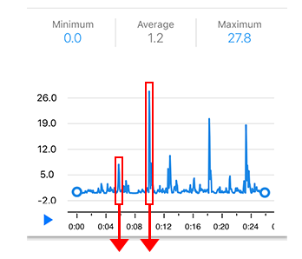
The screenshot above displays the graph obtained from the combination of the five heights. The spikes show the successive drops of the ball from the different heights. The highest spike represents the bouncing of the ball when it was dropped from the highest mark, while the shortest spike represents the bouncing of the ball when it was dropped from the lowest height mark. This implies that the higher the height, the more the gravitational force pulling the ball. The ball hits the surface with higher energy, hence it will bounce higher.
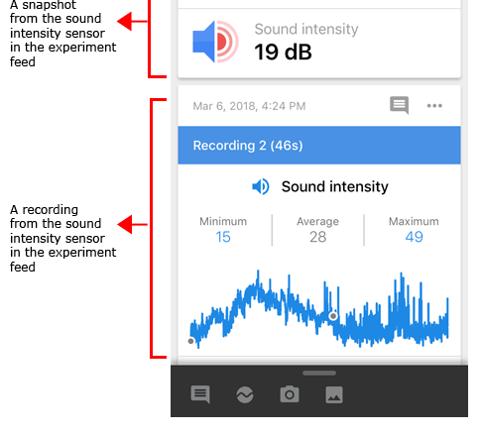
The screenshot above represents the sound intensity which was obtained from the experiment. This shows that some energy was also lost when the sound was produced as the ball hit the surface.

Post-lab questions
- Did the ball bounce to a greater height on the hard ground than on the soft surface?
- How many bounces did the ball make before losing its kinetic energy and seizing from bouncing?
- How do the different bouncing grounds affect the number of bounces a ball makes before completely losing its kinetic energy?
- Hoe does change in surface affect the bounces made by the ball?
- How does the drop/rise in dropping height affect the bounces made by the ball?

Reference
Schwarz, O., Vogt, P., & Kuhn, J. (2013). Acoustic measurements of bouncing balls and the determination of gravitational acceleration. The Physics Teacher, 51(5), 312-313.
Diaconu, O. M. T., Fotin, A., & Cosereanu, C. (2019). Beechwood (Fagus sylvatica L.) flooring structures designed to increase the basketball bounce height. European Journal of Wood and Wood Products, 77(5), 853-860.

